Thank you for choosing Huntington Health where we value your care and are committed to providing you with quality service.
For your first visit:  - Please arrive 15 minutes prior to your scheduled appointment time.  - Bring your insurance cards, picture ID, & referral/doctor’s order for therapy.  - Bring list of current medications/dosages and list of medical procedures/surgeries with dates performed.  - Please ask staff about co-pays at the time of service. CREDIT CARD/CHECK ONLY.  - Hospital policy is to re-verify information at the time of registration.  - Building parking available. Have your car license plate # to pay $3+ and to get partial validation if here for more than 1 hour. CREDIT/DEBIT CARD only. Metropolis app recommended but not required. | What YOU can do to receive better care:  - Be on time for all your appointments. If you cannot be here or will be late, call us at (626) 397-3801. Please provide 24 hour notice for all cancellations.  - Be aware that 3 no-shows will result in cancellation of remaining visits. A new referral from your doctor and/or new authorization may be needed to return.  - Wear or bring appropriate clothing/shoes.  - Follow through with instructions, exercises, and education from your therapists.
 | No photography and videotaping are allowed, including in the patient waiting area and during patient care.

Please check in where your appointment is scheduled, either suite 120 on the 1st floor OR suite 340 on the 3rd floor. If you have any questions or need to re-schedule or cancel, please give us a call at (626) 397-3801 option 2 for suite 120 or option 3 for suite 340. You can also email us at oprehab@huntingtonhealth.org
We look forward to meeting you and serving your health care needs.
Your Outpatient Rehab Team
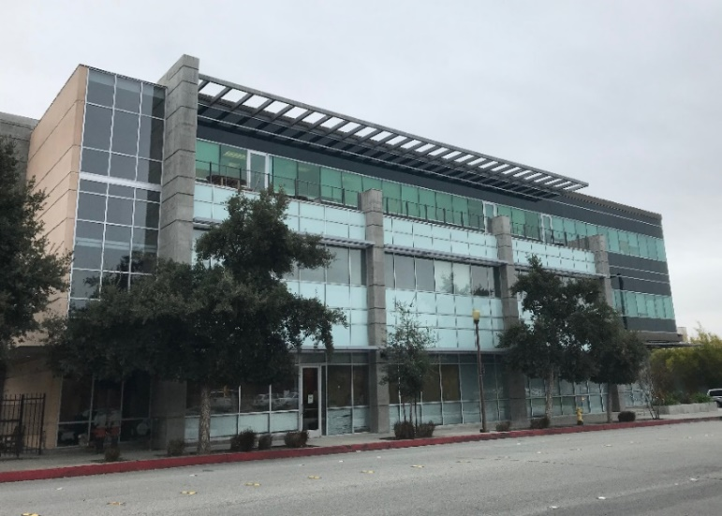
Outpatient Rehab building
630 S. Raymond Ave., Suite 120 (1st floor) & Suite 340 (3rd floor)
Pasadena, CA 91105
P: (626) 397-3801 | F: (626) 397-7173

Parking Instructions
- Underground parking entrance is located on Pico Street.
- Street parking is occasionally available;
be sure to check street signage for restrictions.
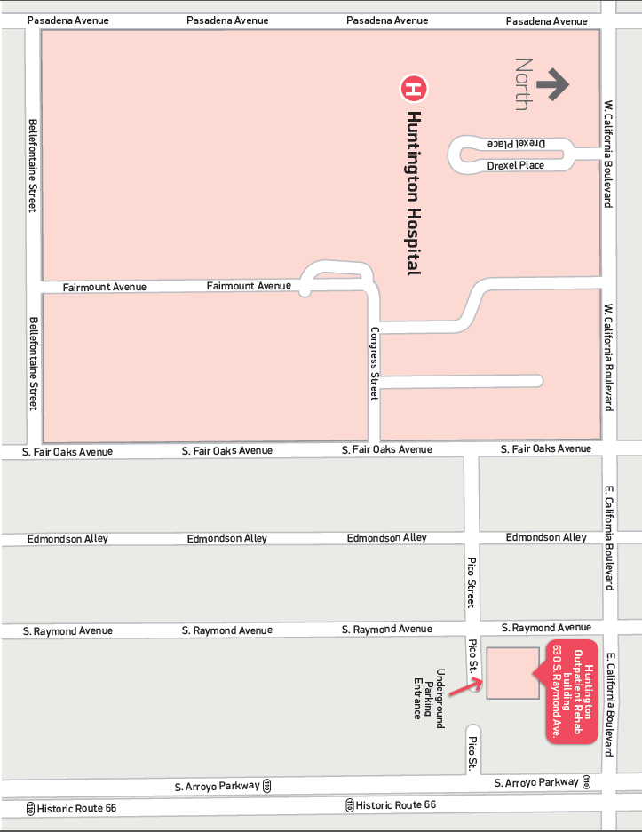
- From the parking structure take the elevator or stairs to the 1st floor (suite 120) or 3rd floor (suite 340).

